Puberty

- Definitions
  - Central puberty
    - Transition from the sexually immature to the sexually mature stage
    - Associated with secondary sexual characteristics and growth spurt
    - Due to activation of the hypothalamic-pituitary-gonadal axis (HPG) axis
  - Adrenarche/pubarche
    - Increased adrenal androgen (DHEAS) production, often before gonadarche
    - Signs of increased androgens: pubic/axillary hair development, apocrine gland maturation (adult body odor), acne
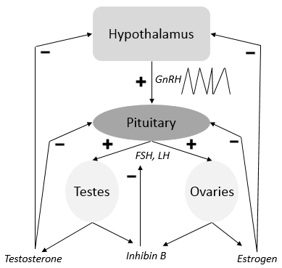
  - Thelarche
    - Onset of breast development
  - Menarche
    - First menstrual period

- Normal Physiology:
  - Continuous GnRH inhibits puberty
  - Puberty starts with pulsatile secretion of GnRH

- Evaluation:
  - History
    - Growth patterns since birth
    - Age of onset and progression of physical puberty changes
    - Past medical history, social, psychological history
    - Exposure to exogenous hormones (medications, lavender, tea tree oils)
    - Signs of CNS abnormalities (headache, vomiting, vision changes)
  - Exam Findings:
    - Progression of physical changes in puberty
      - Girls – Breast development growth spurt (10 cm/yr) menarche (~2 yrs after thelarche)
      - Boys – Testicular growth penile/scrotal enlargement growth spurt (12cm/yr)
    - Tanner Staging System - *Start of puberty indicated by Tanner Stage 2 breasts or testicles
Stage | Breasts | Testicles | Pubic Hair
1 | Prepubertal, papilla elevation | Testicles 1-3mL, prepubertal genitals | No pigmented hair
2 | Breast budding, larger areola, palpable and visible elevated contour* | Testicles 4-6mL, early testicular, penile, and scrotal growth* | Minimal pigmented hair, mainly labial in girls, at base of penis in boys
3 | Enlargement of the breast and areola | Testicles 8-12mL, increased penile length and width, scrotal growth | Dark, coarser hair, spread over mons in girls, and extending midline above penis in boys
4 | Second mound of areola and papilla | Testicles >12mL, increased penis side including breadth, pigmented scrotum | Adult type hair, less than adult distribution
5 | Mature breast | Testicles >15mL, adult size and shape genitalia | Adult distribution, spread to medial thighs
- Bone age
    - Key component in evaluation of normal vs. abnormal puberty
    - Sex steroids cause accelerated skeletal maturity
    - Puberty typically occurs when skeletal age reaches the average age of puberty for that gender – approximately 10.5 years in girls, 12.5 years in boys
  - Determining puberty with laboratory data
    - Single random sample of LH >0.3 U/L using ultrasensitive gonadotropin assay
      - 3rd generation, or “pediatric” immunoassays are best
      - Consider early morning sample, because puberty initially starts with GnRH release at night
    - Historic gold standard is LH obtained 60 minutes after GnRH stimulation

- Abnormal puberty:
  - Precocious puberty
    - Definition – Secondary sexual characteristics in Girls<8 yo (<7 yo in minority girls), Boys <9 yo
      - NOTE: Boys with sexual precocity require careful evaluation because many have underlying disorders.
Gonadotropin dependent (central) | Gonadotropin independent (peripheral)
Tumors (hamartomas/gliomas) | Exogenous exposure
Congenital (hydrocephalus) | Adrenal tumor
Acquired (irradiation, surgery, infection) | Ovarian/testicular tumor
Idiopathic | CAH
 | Hypothyroidism
 | McCune-Albright
  - Delayed puberty
    - Definition – Girls >13yo, Boys >14 yo who are still Tanner Stage 1
    - Types:
      - Constitutional delay: normal variation of the timing and tempo of maturation, delayed bone age
      - Hypogonadotropic hypogonadism: hypothalamic/pituitary disease, Kallman syndrome, chronic illness, malnutrition, exercise, tumors (craniopharyngioma), suppression (hyperthyroidism, hyperprolactinemia, Cushing Syndrome, CAH), panhypopituitarism
      - Gonadal dysgenesis or failure

- Normal pubertal variation
  - Premature thelarche – Isolated breast development without growth acceleration or other pubertal findings
  - Premature adrenarche – Sexual hair (pubic/axillary) without growth acceleration or other pubertal changes

- References:
- Sperling, Mark A. Pediatric Endocrinology 4th Edition.
- Pediatric Endocrinology, Fifth Edition Volume 2. Lifshitz.

