Pediatric Hypoglycemia

- Definition: Hypoglycemia diagnosis is based on plasma glucose (PG) values and never by point of care (POC) values
  - Common in the newborn period (premature, IUGR, sepsis/asphyxia, high basal needs)
  - Transitional hypoglycemia – 30% healthy infants with PG <50 mg/dL in first 24 hours of life
    - >24 hours of life, PG should be >50 mg/dL
  - Beyond 48 hours of life, normal PG concentrations are the same as older children/adults
    - In general, PG >60-70 mg/dL is normal, <50 mg/dL is hypoglycemia

- Normal Physiology:
  - Brain needs continuous supply of glucose (prevents long-term neurologic sequelae, psychomotor retardation, seizures)
  - If glucose unavailable, brain uses ketones (β-hydroxybutyrate, acetoacetate) from fatty acid oxidation as fuel
  - To maintain normal plasma glucose during fasting requires 3 things:
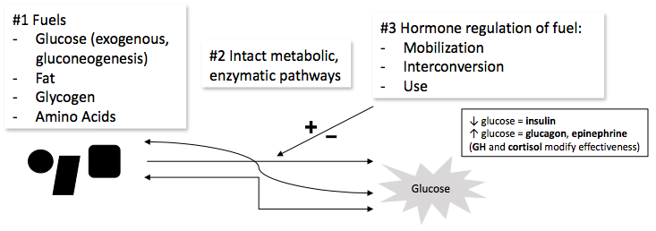
- Clinical Manifestations of Hypoglycemia
  - Autonomic
    - Sweating, hunger, paresthesias, tremors, pallor, anxiety, nausea, palpitations
  - Neuroglycopenic (varies according to age)
    - Warmth, fatigue, weakness, dizziness, headache, inability to concentrate, blurred speech, difficulty speaking, confusion, bizarre behavior, lack of coordination, difficulty walking, coma, seizures

- Differential diagnosis:
  - Are ketones present in response to hypoglycemia?
Hypoglycemia without ketosis | Hypoglycemia with ketosis
Hyperinsulinism (e.g. IDM, congenital hyperinsulinism, transient hyperinsulinism, Beckwith-Wiedemann syndrome, factitious) | Cortisol/ACTH deficiency
Defects in fatty acid oxidation / ketone synthesis | Growth hormone deficiency / hypopituitarism
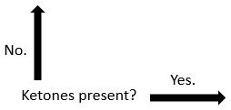 | Disorders of carbohydrate metabolism (e.g. Glycogen storage diseases, Disorders of gluconeogenesis)
 | Disorders of protein metabolism
 | Ingestions (ethanol, salicylates, beta-blockers, quinine, sulfonylureas)
 | Prolonged starvation
 | Increased glucose consumption (sepsis, organ failure)
 | Reactive hypoglycemia (mismatch of insulin secretion to carbohydrate consumption)
 | Ketotic hypoglycemia (otherwise healthy children with repeated AM hypoglycemia and ketosis)
 | Low glycogen stores - Small for gestational age (SGA), prematurity
- Evaluation:
  - History
    - Birth details (weight, GA, maternal health/meds), symptoms of hypoglycemia, age of onset of symptoms, jaundice, association with feeding, potential drug exposures, unusual odors, recurrent “pneumonia” (metabolic acidosis)
  - Physical Exam
    - Stature, microphallus, midline defects, liver size, skin pigmentation, macrosomia, odor, hyperventilation, heart gallop or cardiomyopathy
  - Critical labs (drawn when any glucose <50 mg/dL, and prior to treatment with dextrose)
    - Repeat plasma glucose (confirm hypoglycemia). Insulin, c-peptide, pro-insulin.
    - Ketones (β-hydroxybutyrate in plasma, urinalysis). Growth hormone. Cortisol.
    - Metabolic work-up guided by metabolic experts.
  - Glucagon challenge
    - During hypoglycemia, injection of 1 mg glucagon IV followed by large increase in plasma glucose suggests hyperinsulinism as cause of hypoglycemia.
  - Clues towards hyperinsulinism:
    - Hyperinsulinemia (plasma insulin >2 uU/mL when PG < 50 mg/dL) if sensitive insulin assay.
    - Otherwise, look for evidence of inappropriate insulin effects - hypoketonemia, glycemic response to glucagon challenge, hypo-free fatty acidemia.

- References:
- Sperling, Mark A. Pediatric Endocrinology 4th Edition.
- Pediatric Endocrinology, Fifth Edition Volume 2. Lifshitz.

