Hypocalcemia in Pediatrics
Physiology of Calcium Homeostasis
- Calcium (Ca) is maintained primarily by parathyroid hormone (PTH) and calcitriol (1,25 dihydroxyvitamin D) through actions on the bone, kidney, and GI tract
- PTH:
  - Secreted in response to low Ca (sensed by the calcium-sensing receptor on parathyroid cells).
  - Actions:
    - Bone: PTH mobilizes Ca stores and promotes bone resorption by osteoclasts
    - Kidney: PTH increases Ca reabsorption in distal tubule, increases Phosphorus (Phos) excretion, and activates 1-alpha hydroxylase which converts 25-hydroxyvitamin D to 1,25-vitamin D
    - Net effect = Increased serum Ca, decreased serum Phos
- Calcitriol:
  - GI tract (primary source of calcium): calcitriol enhances intestinal Ca and Phos absorption
  - Net effect = Increase serum Ca and serum Phos

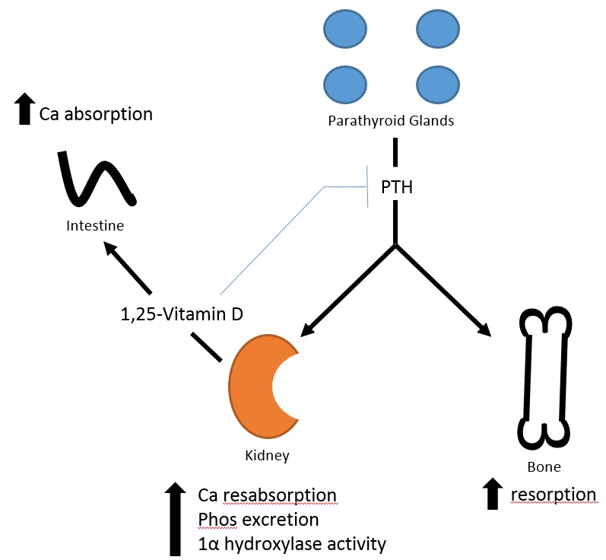
serum Ca and Phos

Hypocalcemia: Defined as [Ca] 2 standard deviations below mean (for age) adjusted for albumin
- Symptoms/Signs: neuromuscular irritability (perioral numbness, paresthesia of hands/feet, muscle cramping, tetany, seizures), diaphoresis, hyperventilation, QT prolongation
- History: dietary assessment, medications (including OTC), surgical history (thyroidectomy), family history of hypocalcemia
- Physical Exam: Trousseau’s sign, Chvostek’s sign, mucocutaneous candidiasis
- Lab Evaluation: total Ca (with albumin), ionized Ca, Phos, magnesium, PTH, 25-OH vitamin D
  - Also consider: 1,25-OH vitamin D, urine calcium/creatinine, alkaline phosphatase
- Differential diagnosis:
  - Neonatal Hypocalcemia
    - Early transient (first 72 hours): maternal factors (diabetes, vit D deficiency, hyperparathyroidism, preeclampsia), neonatal factors (prematurity, low birth weight, birth asphyxia, sepsis or illness)
    - Late transient (>72 hours): high phosphate load in formula
  - Low PTH
    - Abnormal parathyroid gland development or PTH synthesis (DiGeorge syndrome)
    - Activating Ca-sensing receptor mutation
    - Postsurgical or radiation damage to parathyroid gland
    - Parathyroid gland infiltration
    - Autoimmune hypoparathyroidism (isolated vs. APS1: the other two major components are adrenal insufficiency and mucocutaneous candidiasis)
    - Other: Mitochondrial disorders, HDR (hypoparathyroidism, deafness, renal anomaly) syndrome; hypomagnesemia; hyperphosphatemia

  - Elevated PTH
      - Vitamin D deficiency (poor intake, low sun exposure, decreased absorption)
      - Loss of calcium from circulation (tumor lysis, pancreatitis, etc)
      - Defects in vitamin D metabolism or action (liver disease, medications such as antiepileptic drugs and calcium chelators, kidney disease, 25-hydroxylase deficiency)
      - Vitamin D dependent rickets: 1-alpha hydroxylase deficiency, vitamin D resistance
      - Pseudohypoparathyroidism

- Management:
  - Based on underlying etiology
    - Treat hypoparathyroidism with calcitriol, calcium
    - Treat vitamin D 25OH deficiency with Vitamin D3
  - Acute treatment:
    - IV Calcium Gluconate (if symptomatic), 100 mg/kg (max 2g)
    - PO Calcium (if asymptomatic), 50-100 mg/kg/day elemental Ca, divided q6-8h
    - Treat concurrent hypomagnesemia

