Hypercalcemia in Pediatrics
Physiology of Calcium Homeostasis
- Calcium (Ca) is maintained primarily by parathyroid hormone (PTH) and calcitriol (1,25 dihydroxyvitamin D) through actions on the bone, kidney, and GI tract
- PTH:
  - Secreted in response to low Ca (sensed by Calcium-sensing Receptor on parathyroid cells).
  - Actions:
    - Bone: PTH mobilizes Ca stores and promotes bone resorption by osteoclasts
    - Kidney: PTH increases Ca reabsorption in distal tubule, increases Phosphorus (Phos) excretion, and activates 1-alpha hydroxylase to convert 25-hydroxyvitamin D to 1,25-vitamin D
    - Net effect = Increased serum Ca, decreased serum Phos
- Calcitriol:
  - GI tract (primary source of calcium): calcitriol enhances intestinal Ca and Phos absorption
  - Net effect = Increase serum Ca and serum Phos

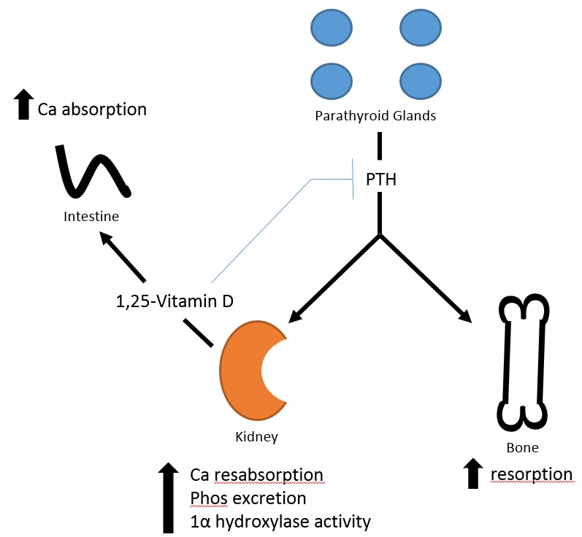
serum Ca and Phos

Hypercalcemia: Defined as [Ca] 2 standard deviations above mean (for age) adjusted for albumin
- Symptoms/Signs: “bones/stones” (nephrolithiasis, bone pain, polyuria), “groans” (abdominal pain, constipation), “psychic overtones” (fatigue, irritability, behavior change, depression, memory loss), failure to thrive, hypotonia, dehydration
- History: dietary assessment, medications (including OTC), family history of hypercalcemia
- Physical Exam: dysmorphic features, bony abnormalities
- Lab Evaluation: total Ca,albumin, ionized Ca, Phos, magnesium, PTH, 25-hydroxyvitamin D
  - Also consider: 1,25-hydroxyvitamin D, urine calcium/creatinine
- Differential diagnosis:
  - PTH-Independent Hypercalcemia (more common)
    - Milk-alkali syndrome
    - Hypervitaminosis D: Vitamin D toxicity, CYP24A1 mutation
    - Immobilization
    - Hypervitaminosis A
    - Granulomatous disorder: subcutaneous fat necrosis of the newborn, TB, sarcoid
    - Endocrinopathies: hyperthyroidism, adrenal insufficiency, pheochromocytoma, severe congenital hypothyroidism
    - Inborn errors of metabolism
    - Williams Syndrome: infantile hypercalcemia
    - Medications: thiazide
    - Phosphate depletion in neonates
    - Hypercalcemia of malignancy (uncommon): PTHrP-mediated, osteolysis, 1-25-mediated
  - PTH-depending Hypercalcemia (less common)
    - Primary hyperparathyroidism
      - Labs: high Ca, low Phos, high PTH
      - Evaluation: Sestamibi, thyroid US to localize enlarged gland(s)
      - Causes (neonatal): maternal hypocalcemia
      - Causes (children): genetic tumors/hyperplasia (MEN1, MEN2A, MEN3, MEN4, HPT-JT), non-syndromic (FIHP), PTH/PTHrP receptor activating mutations, carcinoma, lithium
    - Tertiary Hyperparathyroidism (from chronic renal disease or hypophosphatemic rickets)
    - Familial hypocalciuric hypercalcemia
      - Labs: high Ca, normal/high PTH, Ca/Cr clearance < 0.01
      - No symptoms of high PTH (no nephrolithiasis, bone loss)
      - No treatment needed
- Management:
  - Based on underlying etiology
  - If symptomatic:
    - IVF hydration (with NS)
    - Loop diuretics (enhance urinary Ca excretion but require caution given resulting volume contraction)
    - Calcitonin (short window of effectiveness due to tachyphylaxis)
    - IV bisphosphonates
  - If granulomatous disorder: glucocorticoids
  - If primary hyperparathyroidism: parathyroidectomy, cinacalcet
Available resources/References
- Sperling, Mark A. Pediatric Endocrinology 4th Edition.

